Risk Profiler

View By:

Earthquake Scenarios Probabilistic Risks Training Download About Contact

# Scenario Catalogue

Scenario Catalogue

New? Take The Tour

Sort By:

Magnitude

Scenario Name

Filter By:

Magnitude

Go

Select Scenario by Municipality

Search

Hover over a Scenario to retrieve data:

Magnitude: 4.3

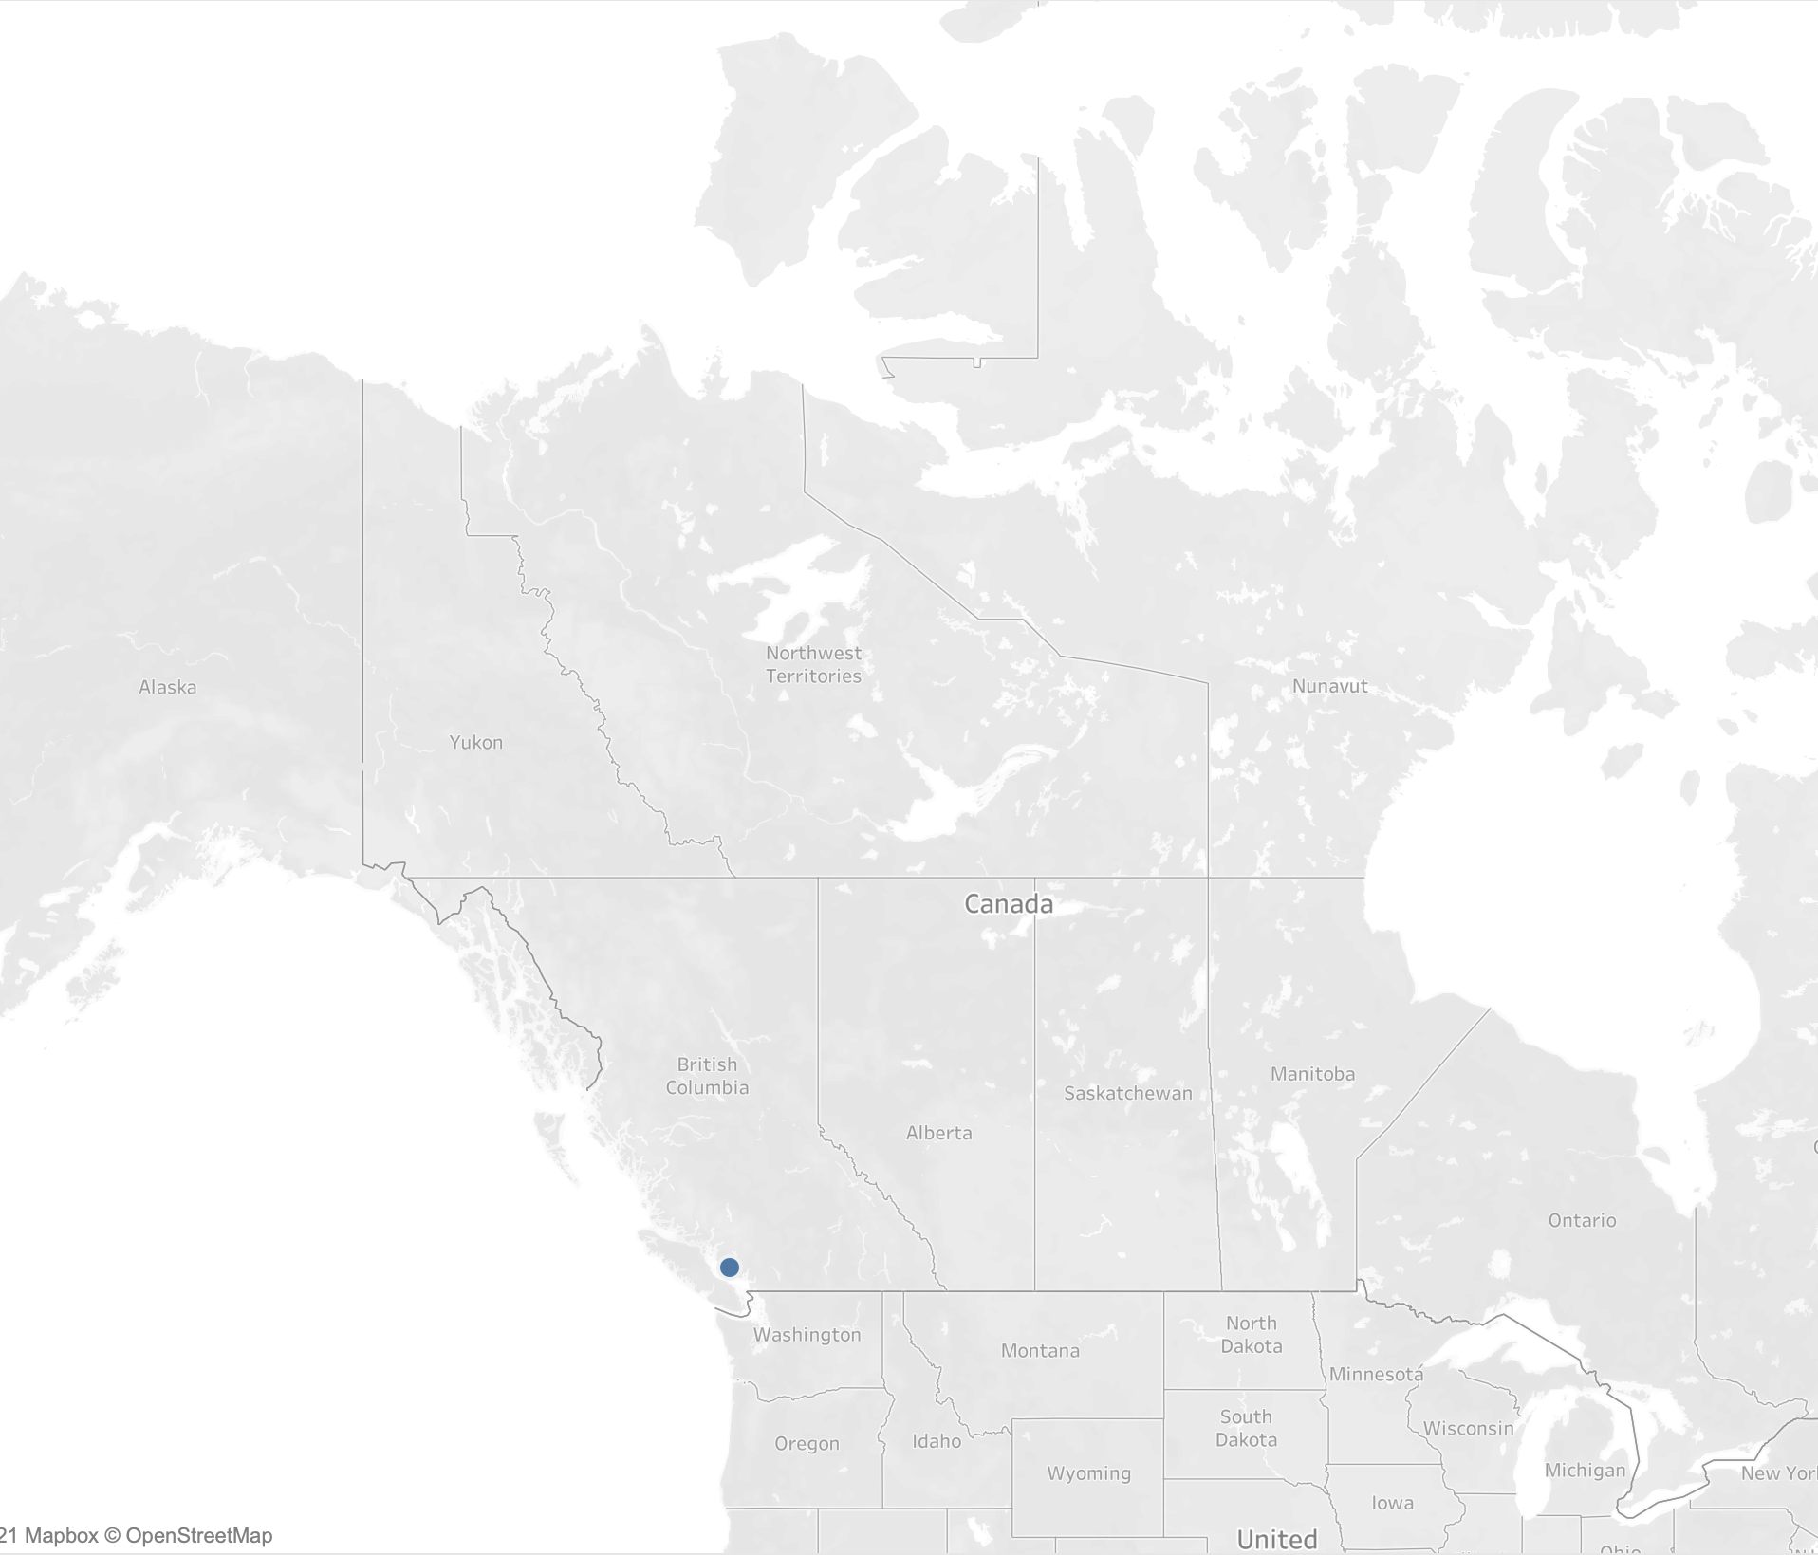

Deaths: 4,323

Dollars: $1,990,999

Damage: 45 damanged buildings

Scenario Name

Magnitude: 5.3

Deaths: 5,443

Dollars: $11,790,999

Damage: 45 damanged buildings

Scenario Name

Magnitude: 2.6 2

Deaths: 4,998

Dollars: $19,990,999

Damage: 21 damanged buildings

Scenario Name

Magnitude: 3.7

Deaths: 2,982

Dollars: $3,000,000 3

Damage: 15 damanged buildings

Scenario Name **+**

Magnitude: 3.7

**-**

Deaths: 2,982

Dollars: $3,000,000

Damage: 15 damanged buildings

Footer